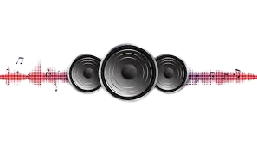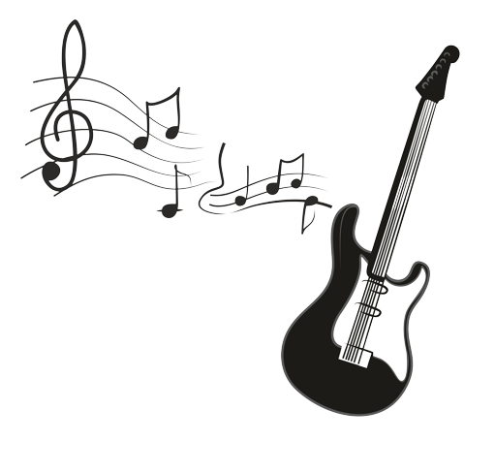

***MUSIC WORLD.***

**VScode E-Project.**

Project Instructor**:**

Azaz Ul Haq.



**PROJECT CERTIFICATION:**

We hereby affirm, to the best of our knowledge and belief, based on inspections, observations, testing of the project and upon reports submitted by others, that this [Music World] is substantially complete and operable. The [project] was completed in accordance with the department’s issued guidelines……

### **PROJECT INSTRUCTOR INFORMATION:**

**NAME:**

### ***SIR AZAZ-UL-HAQ.***

### ***PROJECT NAME:***

**MUSIC WORLD.**

### ***PROJECT MEMBERS:***

|  |  |
| --- | --- |
| **Student1344369** | **HAMMAD RAZA** |
| **Student1349529** | **SUMEET SAFEER SIDDIQUI** |
| **Student1344109** | **ANUS .** |
| **Student1344189** | **ABDUL REHMAN .** |

### ***PROJECT DURATION:***

**14.February.2022.**

**TO,**

**14.March.2022.**

***ACKNOWLEDGEMENT:***

We are thankful to Almighty **ALLAH** that by his grace we have been successful. we presenting on VScode in your hands.

This is our First Year Semester E-Project. We have tried our best & struggled for a better outlook to come. This project has been developed in VScode. We choose to make Webpage for **Music World** as a project. We find easy to do coding in VScode.

We earnestly hope that this project will provide all the necessarily information required for the user to fulfill their inspiration. However, suggestions for improvement of the project will be thankful received & acknowledge.

**THANKING YOU....**

***PROJECT SYNOPSIS:***

***PROJECT* *TITLE:***

*Music World*.

**SEMESTER:**

*Semester 1 (CPISM).*

***Center Name:***

*Aptech North Karachi.*

**PROJECT INSTRUCTOR:**

*Mr. Azaz-Ul-Haq.*

**CURRICULUM CODE:**

*7062.*

***Table of Contents:***

* VScode E-project.....................................................
* Submitted To.....................................................................
* Project Instructor...............................................................
* Curriculum Code................................................................
* Project Certification...........................................................
* Acknowledgement.............................................................
* User Guide..........................................................................
* Developer’s Guide...............................................................
* Source code………………………………………………………………….
* Snapshots…………………………………………………………………..
* Dfd………………………………………………………………………….
* Flowchat……………………………………………………………

***Group Members:***

|  |  |
| --- | --- |
| ***NAME:*** | ***EROLL NUMBER*** *:*ENT Number |
| **HAMMAD RAZA** | **Student1344369** |
| **SUMEET SAFEER SIDDIQUI** | **Student1349529** |
| **ANUS** | **Student1344109** |
| **ABDUL REHMAN** | **Student1344189** |

***OBJECTIVE:***

“This project objective is to create a sample website that is required for a real-life scenario.

The objective for this project is to enhance our techniques and work as a team.”

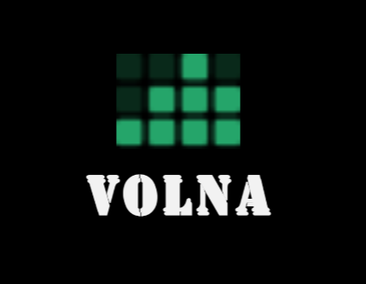

* A Menu should be created which would categorize all the information about the features provided in the Site For e.g. a Menu for Various categories of music, a Menu for releases in the current year etc etc.
* The categories of music can be
  1. Rock
  2. Jazz
  3. Pop
  4. Rap
  5. Classical
* These categories can be further divided into subcategories.
* On clicking on any of the category would be able to give all the related information as
* Artists details
  1. Personal details
  2. Career achievements
  3. Collection
* Various albums in the respective category.

1. Album release details
2. Artist
3. Songs

* Instruments related to the category
* Events taking place in that category
* Site should also be displaying new releases, best of the year, collections from top composers.
* It should also display the reviews about various albums or artists under reviews section.
* User should be able to perform searches by
  1. Artist
  2. Album
  3. Release Date of album.
* There would be two types of users: registered and non-registered users.
* Registered users should be able to download the complete album whereas non-registered users should only be able to listen the album but no downloading allowed for them.
* Site should also display the related articles.

***User’s Guide***

**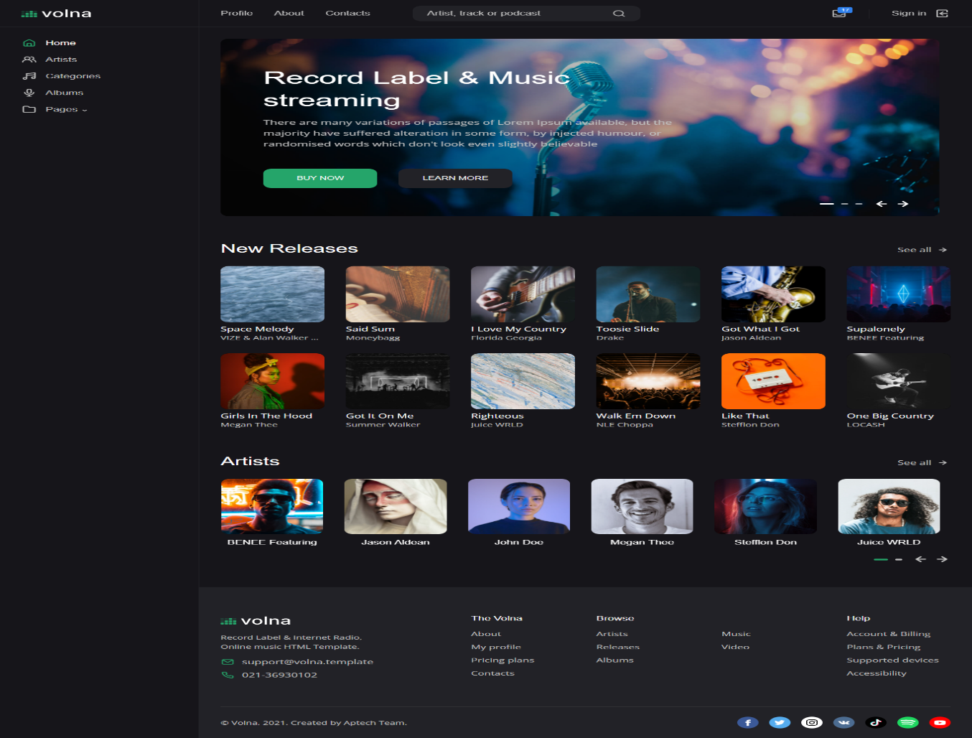*Home Page***

This is a home page its shows you what things in our Music ….and it show how to go next page.

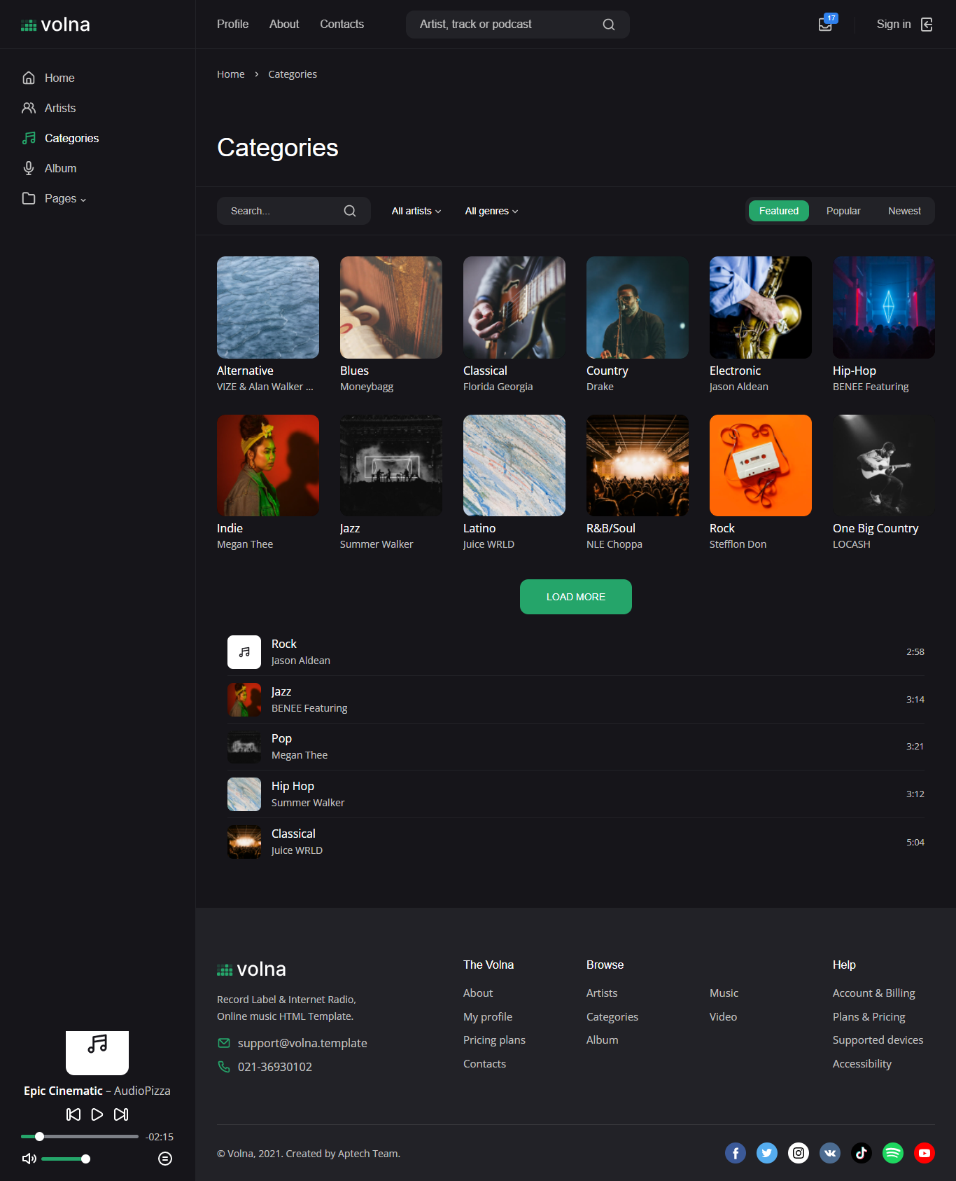***CATEGORIES:***

Categories has different options which shows you a different music…Different pages with different songs…

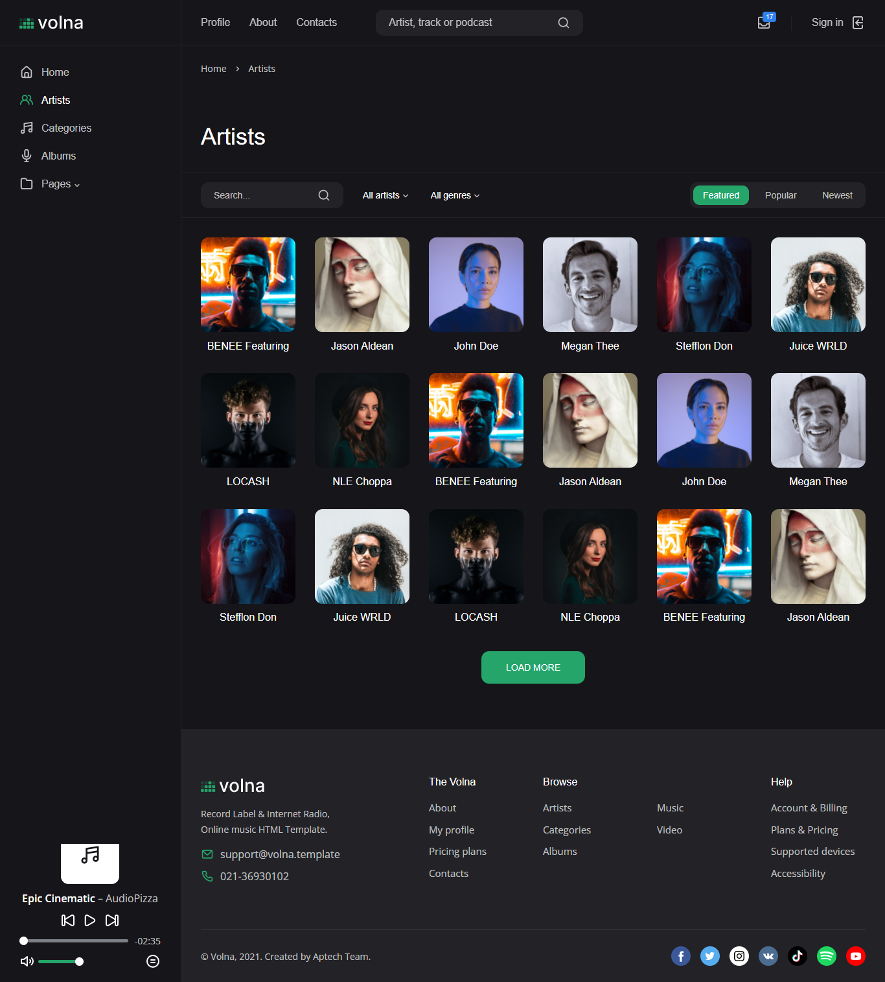***ARTISTS:***

Artist page has more categories which shows that different artist...1st gallery is for Categories and 2nd gallery is for our Artist...

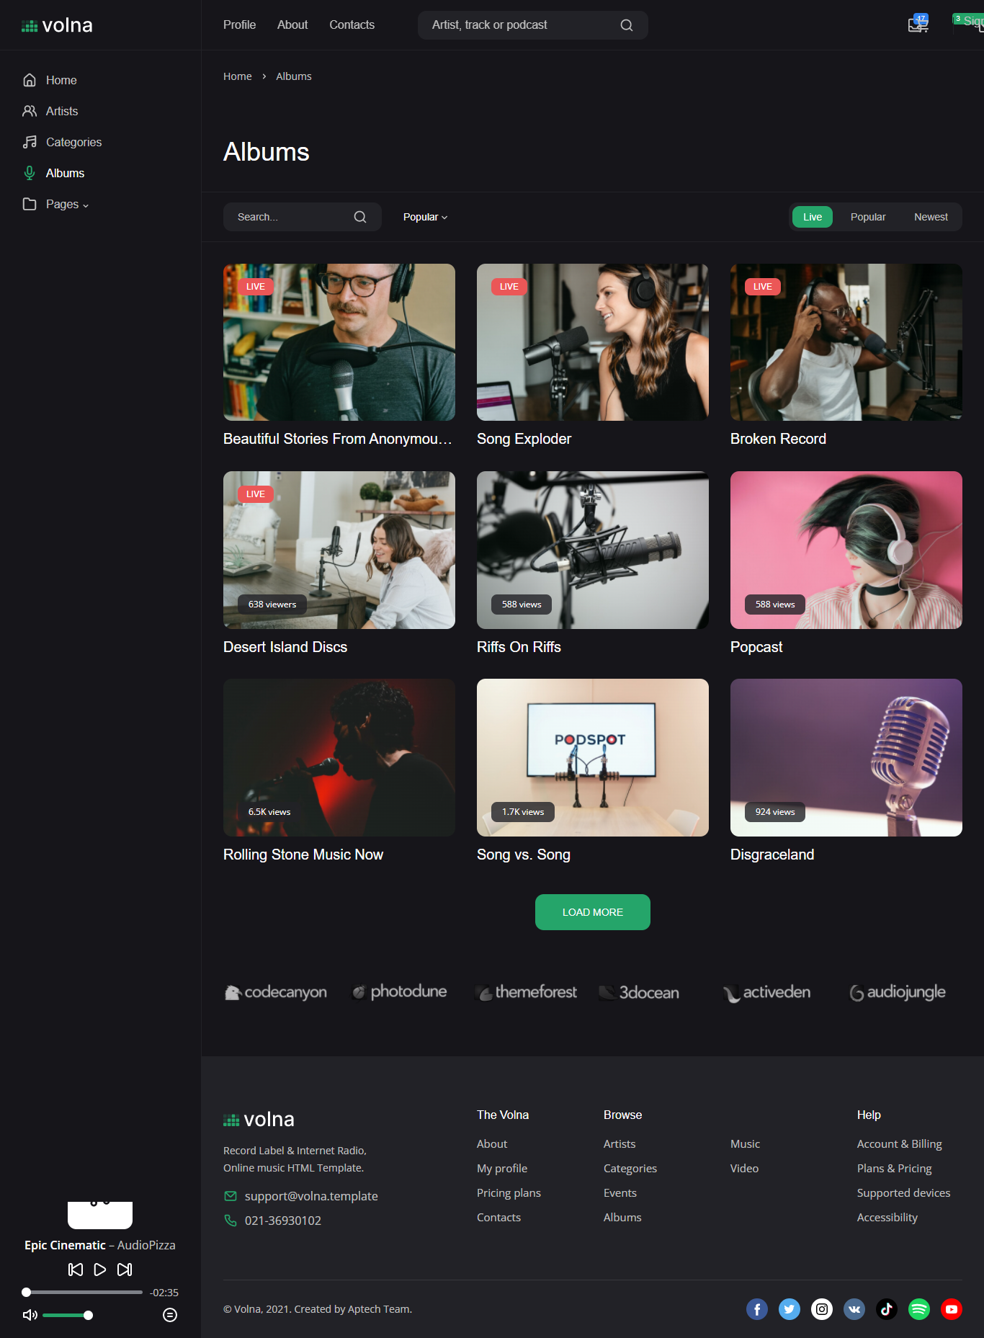***SONGS:***

This page shows our Music ….

***SONGS Of The Month:***

This page shows our Music which people like the most…

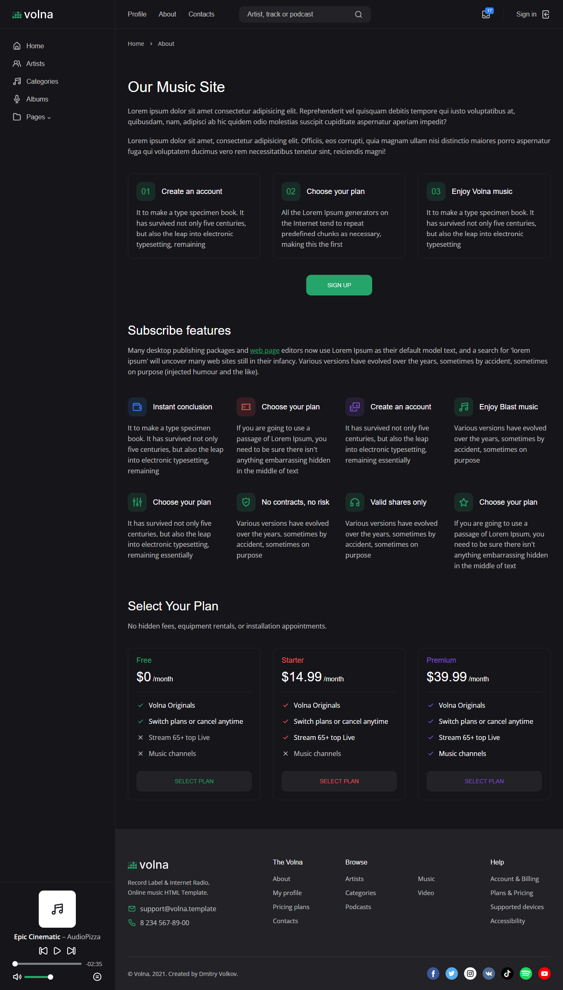***About Us:***

This page show information about our Music’s or our plans…

***Contact us***

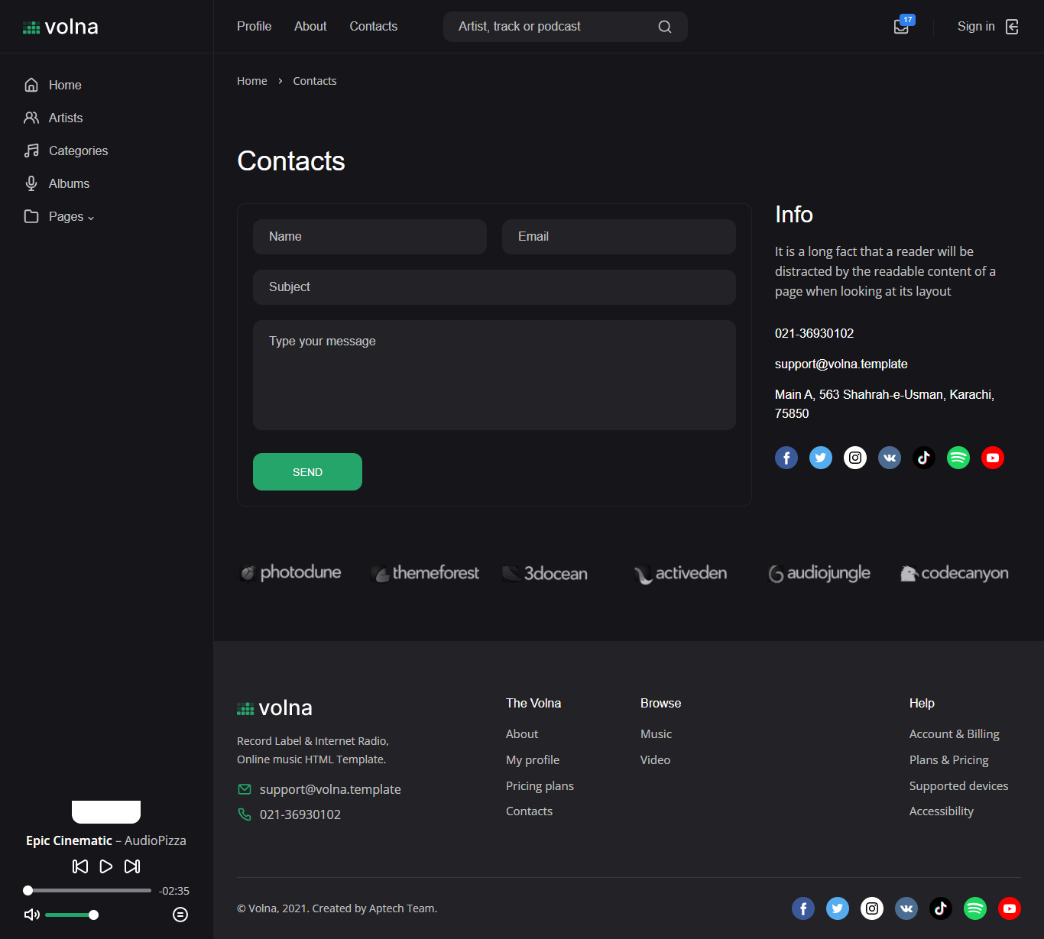

This page shows how to contact us…

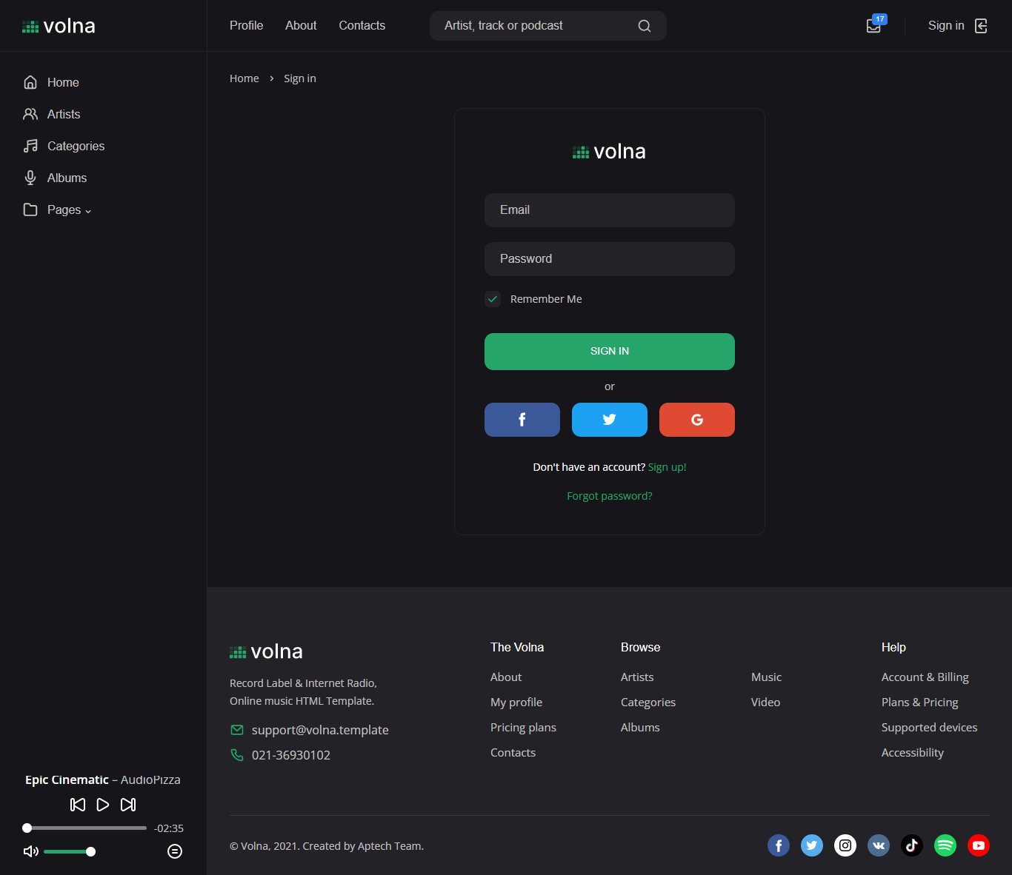***SIGN IN:***

This is sign in page, where you easily can sign in and download your favorite songs…

***Footer:***

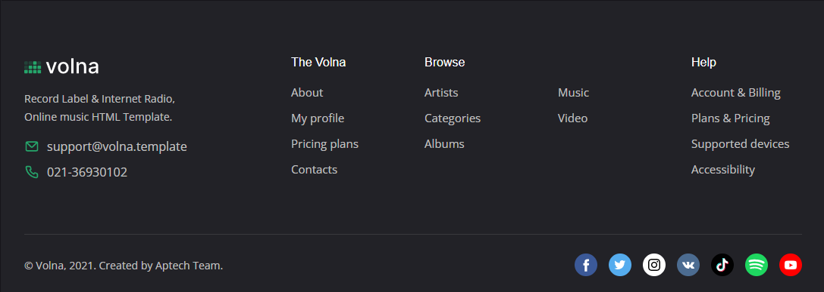

This is the footer of our website…

**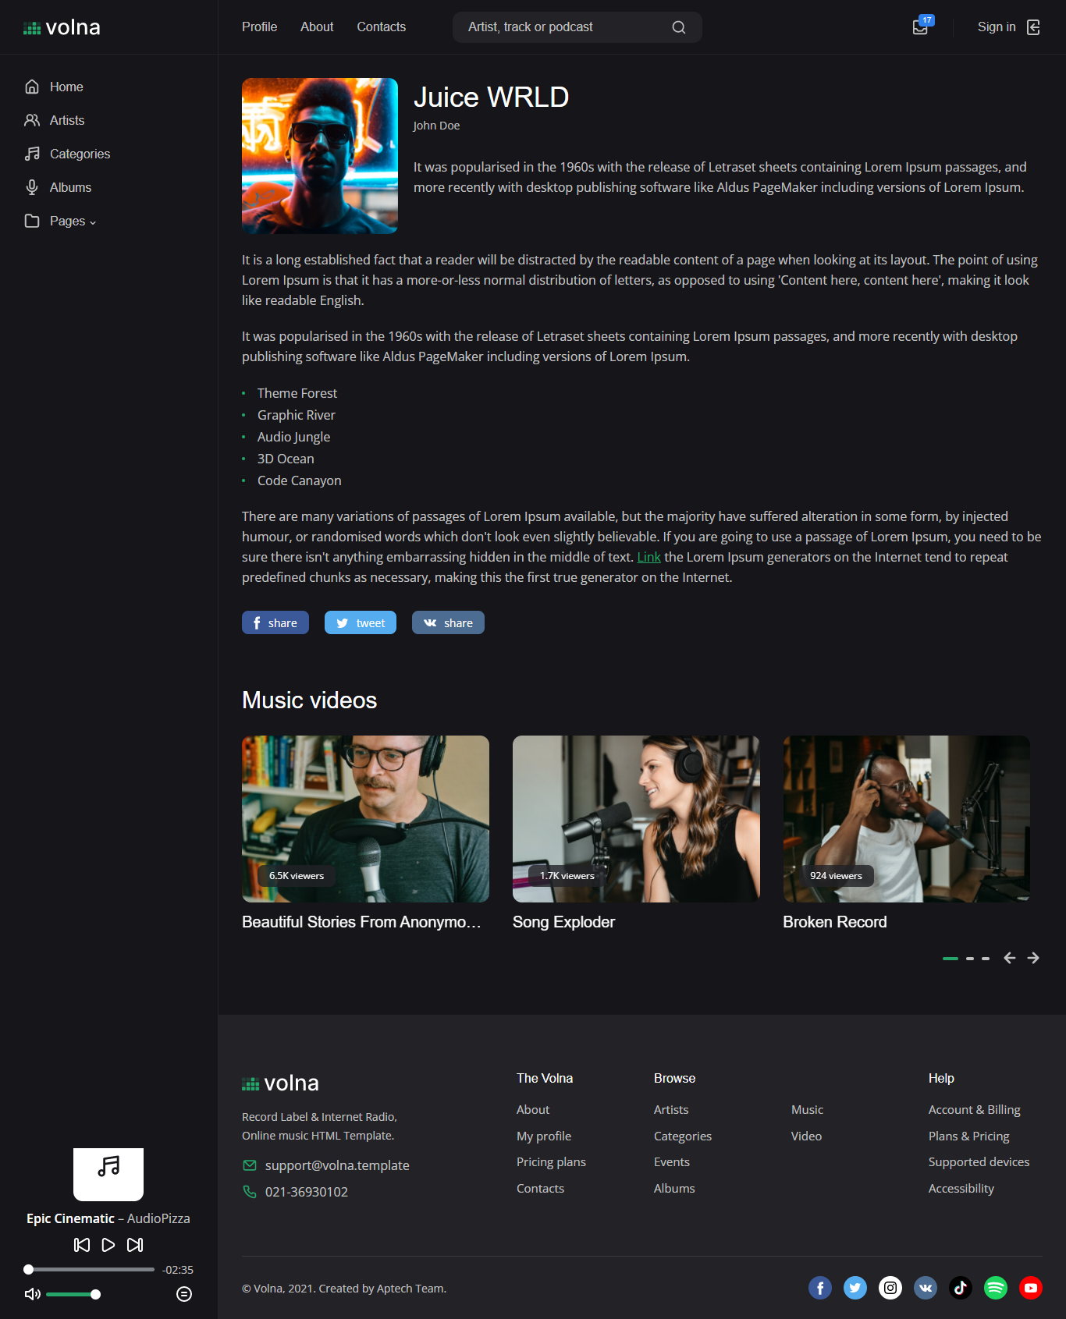*ARTISTS DETAIL:***

This page shows all details of artist…

***DATA FLOW DIAGRAM:***

***Developers Guide***

***Website Code:***

* ***Home page coding:***
* **Navbar coding**:

<!DOCTYPE html>

<html lang="en">

<head>

<meta charset="utf-8">

<meta name="viewport" content="width=device-width, initial-scale=1, shrink-to-fit=no">

<!-- CSS -->

<link rel="stylesheet" href="css/bootstrap-reboot.min.css">

<link rel="stylesheet" href="css/bootstrap-grid.min.css">

<link rel="stylesheet" href="css/owl.carousel.min.css">

<link rel="stylesheet" href="css/magnific-popup.css">

<link rel="stylesheet" href="css/select2.min.css">

<link rel="stylesheet" href="css/paymentfont.min.css">

<link rel="stylesheet" href="css/slider-radio.css">

<link rel="stylesheet" href="css/plyr.css">

<link rel="stylesheet" href="css/main.css">

<!-- Favicons -->

<link rel="icon" type="image/png" href="icon/favicon-32x32.png" sizes="32x32">

<link rel="apple-touch-icon" href="icon/favicon-32x32.png">

<meta name="description" content="">

<meta name="keywords" content="">

<meta name="author" content="Dmitry Volkov">

<title>Volna – Record label & Music streaming HTML Template</title>

</head>

<body>

<!-- header -->

<header class="header">

<div class="header__content">

<div class="header__logo">

<a href="index.html">

<img src="img/logo.svg" alt="">

</a>

</div>

<nav class="header__nav">

<a href="profile.html">Profile</a>

<a href="about.html">About</a>

<a href="contacts.html">Contacts</a>

</nav>

<form action="#" class="header__search">

<input type="text" placeholder="Artist, track or podcast">

<button type="button"><svg xmlns="http://www.w3.org/2000/svg" viewBox="0 0 24 24"><path d="M21.71,20.29,18,16.61A9,9,0,1,0,16.61,18l3.68,3.68a1,1,0,0,0,1.42,0A1,1,0,0,0,21.71,20.29ZM11,18a7,7,0,1,1,7-7A7,7,0,0,1,11,18Z"/></svg></button>

<button type="button" class="close"><svg xmlns="http://www.w3.org/2000/svg" viewBox="0 0 24 24"><path d="M13.41,12l6.3-6.29a1,1,0,1,0-1.42-1.42L12,10.59,5.71,4.29A1,1,0,0,0,4.29,5.71L10.59,12l-6.3,6.29a1,1,0,0,0,0,1.42,1,1,0,0,0,1.42,0L12,13.41l6.29,6.3a1,1,0,0,0,1.42,0,1,1,0,0,0,0-1.42Z"/></svg></button>

</form>

<div class="header__actions">

<div class="header__action header__action--search">

<button class="header__action-btn" type="button"><svg xmlns="http://www.w3.org/2000/svg" viewBox="0 0 24 24"><path d="M21.71,20.29,18,16.61A9,9,0,1,0,16.61,18l3.68,3.68a1,1,0,0,0,1.42,0A1,1,0,0,0,21.71,20.29ZM11,18a7,7,0,1,1,7-7A7,7,0,0,1,11,18Z"/></svg></button>

</div>

<div class="header__action header__action--note">

<span>17</span>

<a href="#" class="header__action-btn"><svg xmlns="http://www.w3.org/2000/svg" viewBox="0 0 24 24"><path d="M19.05566,2h-14a3.00328,3.00328,0,0,0-3,3V19a3.00328,3.00328,0,0,0,3,3h14a3.00328,3.00328,0,0,0,3-3V5A3.00328,3.00328,0,0,0,19.05566,2Zm-14,2h14a1.001,1.001,0,0,1,1,1v8H17.59082a1.99687,1.99687,0,0,0-1.66406.89062L14.52051,16H9.59082L8.18457,13.89062A1.99687,1.99687,0,0,0,6.52051,13H4.05566V5A1.001,1.001,0,0,1,5.05566,4Zm14,16h-14a1.001,1.001,0,0,1-1-1V15H6.52051l1.40625,2.10938A1.99687,1.99687,0,0,0,9.59082,18h4.92969a1.99687,1.99687,0,0,0,1.66406-.89062L17.59082,15h2.46484v4A1.001,1.001,0,0,1,19.05566,20Z"/></svg></a>

<div class="header__drop">

<a href="#" class="header__all">View all</a>

<div class="header__note header__note--succ">

<svg xmlns="http://www.w3.org/2000/svg" viewBox="0 0 24 24"><path d="M14.72,8.79l-4.29,4.3L8.78,11.44a1,1,0,1,0-1.41,1.41l2.35,2.36a1,1,0,0,0,.71.29,1,1,0,0,0,.7-.29l5-5a1,1,0,0,0,0-1.42A1,1,0,0,0,14.72,8.79ZM12,2A10,10,0,1,0,22,12,10,10,0,0,0,12,2Zm0,18a8,8,0,1,1,8-8A8,8,0,0,1,12,20Z"/></svg>

<p><a href="#modal-info2" class="open-modal">Payment #51</a> was successful!</p>

<span>1 hour ago</span>

</div>

<div class="header__note header__note--fail">

<svg xmlns="http://www.w3.org/2000/svg" viewBox="0 0 24 24"><path d="M15.71,8.29a1,1,0,0,0-1.42,0L12,10.59,9.71,8.29A1,1,0,0,0,8.29,9.71L10.59,12l-2.3,2.29a1,1,0,0,0,0,1.42,1,1,0,0,0,1.42,0L12,13.41l2.29,2.3a1,1,0,0,0,1.42,0,1,1,0,0,0,0-1.42L13.41,12l2.3-2.29A1,1,0,0,0,15.71,8.29Zm3.36-3.36A10,10,0,1,0,4.93,19.07,10,10,0,1,0,19.07,4.93ZM17.66,17.66A8,8,0,1,1,20,12,7.95,7.95,0,0,1,17.66,17.66Z"/></svg>

<p><a href="#modal-info3" class="open-modal">Payment #50</a> failed!</p>

<span>2 hours ago</span>

</div>

<div class="header__note header__note--info">

<svg xmlns="http://www.w3.org/2000/svg" viewBox="0 0 24 24"><path d="M12,2A10,10,0,1,0,22,12,10.01114,10.01114,0,0,0,12,2Zm0,18a8,8,0,1,1,8-8A8.00917,8.00917,0,0,1,12,20Zm0-8.5a1,1,0,0,0-1,1v3a1,1,0,0,0,2,0v-3A1,1,0,0,0,12,11.5Zm0-4a1.25,1.25,0,1,0,1.25,1.25A1.25,1.25,0,0,0,12,7.5Z"/></svg>

<p><a href="#modal-info4" class="open-modal">Example</a> of notification.</p>

<span>2 hours ago</span>

</div>

<div class="header__note header__note--gift">

<svg xmlns="http://www.w3.org/2000/svg" viewBox="0 0 24 24"><path d="M18,7h-.35A3.45,3.45,0,0,0,18,5.5a3.49,3.49,0,0,0-6-2.44A3.49,3.49,0,0,0,6,5.5,3.45,3.45,0,0,0,6.35,7H6a3,3,0,0,0-3,3v2a1,1,0,0,0,1,1H5v6a3,3,0,0,0,3,3h8a3,3,0,0,0,3-3V13h1a1,1,0,0,0,1-1V10A3,3,0,0,0,18,7ZM11,20H8a1,1,0,0,1-1-1V13h4Zm0-9H5V10A1,1,0,0,1,6,9h5Zm0-4H9.5A1.5,1.5,0,1,1,11,5.5Zm2-1.5A1.5,1.5,0,1,1,14.5,7H13ZM17,19a1,1,0,0,1-1,1H13V13h4Zm2-8H13V9h5a1,1,0,0,1,1,1Z"/></svg>

<p><a href="#modal-info5" class="open-modal">You have received a gift!</a></p>

<span>4 hours ago</span>

</div>

</div>

</div>

<div class="header__action header__action--signin">

<a class="header__action-btn" href="signin.html">

<span>Sign in</span>

<svg xmlns="http://www.w3.org/2000/svg" viewBox="0 0 24 24"><path d="M20,12a1,1,0,0,0-1-1H11.41l2.3-2.29a1,1,0,1,0-1.42-1.42l-4,4a1,1,0,0,0-.21.33,1,1,0,0,0,0,.76,1,1,0,0,0,.21.33l4,4a1,1,0,0,0,1.42,0,1,1,0,0,0,0-1.42L11.41,13H19A1,1,0,0,0,20,12ZM17,2H7A3,3,0,0,0,4,5V19a3,3,0,0,0,3,3H17a3,3,0,0,0,3-3V16a1,1,0,0,0-2,0v3a1,1,0,0,1-1,1H7a1,1,0,0,1-1-1V5A1,1,0,0,1,7,4H17a1,1,0,0,1,1,1V8a1,1,0,0,0,2,0V5A3,3,0,0,0,17,2Z"/></svg>

</a>

</div>

</div>

<button class="header__btn" type="button">

<span></span>

<span></span>

<span></span>

</button>

</div>

</header>

<!-- end header -->

<! -- sidebar -->

<div class="sidebar">

<!-- sidebar logo -->

<div class="sidebar__logo">

<img src="img/logo.svg" alt="">

</div>

<!-- end sidebar logo -->

<!-- sidebar nav -->

<ul class="sidebar__nav">

<li class="sidebar__nav-item">

<a href="index.html" class="sidebar__nav-link sidebar__nav-link--active"><svg xmlns="http://www.w3.org/2000/svg" viewBox="0 0 24 24"><path d="M20,8h0L14,2.74a3,3,0,0,0-4,0L4,8a3,3,0,0,0-1,2.26V19a3,3,0,0,0,3,3H18a3,3,0,0,0,3-3V10.25A3,3,0,0,0,20,8ZM14,20H10V15a1,1,0,0,1,1-1h2a1,1,0,0,1,1,1Zm5-1a1,1,0,0,1-1,1H16V15a3,3,0,0,0-3-3H11a3,3,0,0,0-3,3v5H6a1,1,0,0,1-1-1V10.25a1,1,0,0,1,.34-.75l6-5.25a1,1,0,0,1,1.32,0l6,5.25a1,1,0,0,1,.34.75Z"></path></svg> <span>Home</span></a>

</li>

<li class="sidebar__nav-item">

<a href="artists.html" class="sidebar__nav-link"><svg xmlns="http://www.w3.org/2000/svg" viewBox="0 0 24 24"><path d="M12.3,12.22A4.92,4.92,0,0,0,14,8.5a5,5,0,0,0-10,0,4.92,4.92,0,0,0,1.7,3.72A8,8,0,0,0,1,19.5a1,1,0,0,0,2,0,6,6,0,0,1,12,0,1,1,0,0,0,2,0A8,8,0,0,0,12.3,12.22ZM9,11.5a3,3,0,1,1,3-3A3,3,0,0,1,9,11.5Zm9.74.32A5,5,0,0,0,15,3.5a1,1,0,0,0,0,2,3,3,0,0,1,3,3,3,3,0,0,1-1.5,2.59,1,1,0,0,0-.5.84,1,1,0,0,0,.45.86l.39.26.13.07a7,7,0,0,1,4,6.38,1,1,0,0,0,2,0A9,9,0,0,0,18.74,11.82Z"/></svg> <span>Artists</span></a>

</li>

<li class="sidebar__nav-item">

<a href="releases.html" class="sidebar__nav-link"><svg xmlns="http://www.w3.org/2000/svg" viewBox="0 0 24 24"><path d="M21.65,2.24a1,1,0,0,0-.8-.23l-13,2A1,1,0,0,0,7,5V15.35A3.45,3.45,0,0,0,5.5,15,3.5,3.5,0,1,0,9,18.5V10.86L20,9.17v4.18A3.45,3.45,0,0,0,18.5,13,3.5,3.5,0,1,0,22,16.5V3A1,1,0,0,0,21.65,2.24ZM5.5,20A1.5,1.5,0,1,1,7,18.5,1.5,1.5,0,0,1,5.5,20Zm13-2A1.5,1.5,0,1,1,20,16.5,1.5,1.5,0,0,1,18.5,18ZM20,7.14,9,8.83v-3L20,4.17Z"/></svg> <span>Categories</span></a>

</li>

<li class="sidebar__nav-item">

<a href="podcasts.html" class="sidebar__nav-link"><svg xmlns="http://www.w3.org/2000/svg" viewBox="0 0 24 24"><path d="M12,15a4,4,0,0,0,4-4V5A4,4,0,0,0,8,5v6A4,4,0,0,0,12,15ZM10,5a2,2,0,0,1,4,0v6a2,2,0,0,1-4,0Zm10,6a1,1,0,0,0-2,0A6,6,0,0,1,6,11a1,1,0,0,0-2,0,8,8,0,0,0,7,7.93V21H9a1,1,0,0,0,0,2h6a1,1,0,0,0,0-2H13V18.93A8,8,0,0,0,20,11Z"/></svg> <span>Albums</span></a>

</li>

<!-- collapse -->

<li class="sidebar__nav-item">

<a class="sidebar__nav-link" data-toggle="collapse" href="#collapseMenu1" role="button" aria-expanded="false" aria-controls="collapseMenu1"><svg xmlns="http://www.w3.org/2000/svg" viewBox="0 0 24 24"><path d="M19,5.5H12.72l-.32-1a3,3,0,0,0-2.84-2H5a3,3,0,0,0-3,3v13a3,3,0,0,0,3,3H19a3,3,0,0,0,3-3V8.5A3,3,0,0,0,19,5.5Zm1,13a1,1,0,0,1-1,1H5a1,1,0,0,1-1-1V5.5a1,1,0,0,1,1-1H9.56a1,1,0,0,1,.95.68l.54,1.64A1,1,0,0,0,12,7.5h7a1,1,0,0,1,1,1Z"/></svg> <span>Pages</span> <svg xmlns="http://www.w3.org/2000/svg" viewBox="0 0 24 24"><path d="M17,9.17a1,1,0,0,0-1.41,0L12,12.71,8.46,9.17a1,1,0,0,0-1.41,0,1,1,0,0,0,0,1.42l4.24,4.24a1,1,0,0,0,1.42,0L17,10.59A1,1,0,0,0,17,9.17Z"/></svg></a>

<div class="collapse" id="collapseMenu1">

<ul class="sidebar__menu sidebar__menu--scroll">

<li><a href="artist.html">Artist</a></li>

<li><a href="release.html">Release</a></li>

<li><a href="article.html">Article</a></li>

<li><a href="cart.html">Cart</a></li>

<li><a href="profile.html">Profile</a></li>

<li><a href="about.html">About</a></li>

<li><a href="contacts.html">Contacts</a></li>

<li><a href="pricing.html">Pricing plans</a></li>

<li><a href="privacy.html">Privacy policy</a></li>

<li><a href="signin.html">Sign in</a></li>

<li><a href="signup.html">Sign up</a></li>

<li><a href="forgot.html">Forgot password</a></li>

<li><a href="404.html">404 Page</a></li>

</ul>

</div>

</li>

<!-- end collapse -->

</ul>

<!-- end sidebar nav -->

</div>

<!-- end sidebar -->

<! -- player -->

<div class="player">

<div class="player__cover">

<img src="img/covers/cover.svg" alt="">

</div>

<div class="player__content">

<span class="player__track"><b class="player__title">Epic Cinematic</b> – <span class="player__artist">AudioPizza</span></span>

<audio src="https://dmitryvolkov.me/demo/blast2.0/audio/12071151_epic-cinematic-trailer_by_audiopizza_preview.mp3" id="audio" controls></audio>

</div>

</div>

<button class="player__btn" type="button"><svg xmlns="http://www.w3.org/2000/svg" viewBox="0 0 24 24"><path d="M21.65,2.24a1,1,0,0,0-.8-.23l-13,2A1,1,0,0,0,7,5V15.35A3.45,3.45,0,0,0,5.5,15,3.5,3.5,0,1,0,9,18.5V10.86L20,9.17v4.18A3.45,3.45,0,0,0,18.5,13,3.5,3.5,0,1,0,22,16.5V3A1,1,0,0,0,21.65,2.24ZM5.5,20A1.5,1.5,0,1,1,7,18.5,1.5,1.5,0,0,1,5.5,20Zm13-2A1.5,1.5,0,1,1,20,16.5,1.5,1.5,0,0,1,18.5,18ZM20,7.14,9,8.83v-3L20,4.17Z"/></svg> Player</button>

<! -- end player -->

<! -- main content -->

<main class="main">

<div class="container-fluid">

<!-- slider -->

<section class="row">

<div class="col-12">

<div class="hero owl-carousel" id="hero">

<div class="hero__slide" data-bg="img/home/slide1.jpg">

<h1 class="hero__title">Record Label & Music streaming</h1>

<p class="hero__text">There are many variations of passages of Lorem Ipsum available, but the majority have suffered alteration in some form, by injected humour, or randomised words which don't look even slightly believable</p>

<div class="hero__btns">

<a href="#" class="hero__btn hero__btn--green">Buy now</a>

<a href="#" class="hero__btn">Learn more</a>

</div>

</div>

<div class="hero__slide" data-bg="img/home/slide2.jpg">

<h2 class="hero__title">Metallica and Slipknot feature in trailer for ‘Long Live Rock’ documentary</h2>

<p class="hero__text">It also features Rage Against the Machine, Guns N' Roses and a number of others</p>

<div class="hero__btns">

<a href="#" class="hero__btn hero__btn--green">Learn more</a>

<a href="http://www.youtube.com/watch?v=0O2aH4XLbto" class="hero__btn hero__btn--video open-video"><svg xmlns="http://www.w3.org/2000/svg" viewBox="0 0 24 24"><path d="M16,10.27,11,7.38A2,2,0,0,0,8,9.11v5.78a2,2,0,0,0,1,1.73,2,2,0,0,0,2,0l5-2.89a2,2,0,0,0,0-3.46ZM15,12l-5,2.89V9.11L15,12ZM12,2A10,10,0,1,0,22,12,10,10,0,0,0,12,2Zm0,18a8,8,0,1,1,8-8A8,8,0,0,1,12,20Z"/></svg> Watch video</a>

</div>

</div>

<div class="hero__slide" data-bg="img/home/slide3.jpg">

<h2 class="hero__title">New Artist of Our Label</h2>

<p class="hero__text">There are many variations of passages of Lorem Ipsum available, but the majority have suffered alteration in some form, by injected humour, or randomised words which don't look even slightly believable</p>

<div class="hero__btns">

<a href="#" class="hero__btn">Learn more</a>

</div>

</div>

</div>

<button class="main__nav main__nav--hero main__nav--prev" data-nav="#hero" type="button"><svg xmlns="http://www.w3.org/2000/svg" viewBox="0 0 24 24"><path d="M17,11H9.41l3.3-3.29a1,1,0,1,0-1.42-1.42l-5,5a1,1,0,0,0-.21.33,1,1,0,0,0,0,.76,1,1,0,0,0,.21.33l5,5a1,1,0,0,0,1.42,0,1,1,0,0,0,0-1.42L9.41,13H17a1,1,0,0,0,0-2Z"/></svg></button>

<button class="main__nav main__nav--hero main__nav--next" data-nav="#hero" type="button"><svg xmlns="http://www.w3.org/2000/svg" viewBox="0 0 24 24"><path d="M17.92,11.62a1,1,0,0,0-.21-.33l-5-5a1,1,0,0,0-1.42,1.42L14.59,11H7a1,1,0,0,0,0,2h7.59l-3.3,3.29a1,1,0,0,0,0,1.42,1,1,0,0,0,1.42,0l5-5a1,1,0,0,0,.21-.33A1,1,0,0,0,17.92,11.62Z"/></svg></button>

</div>

</section>

<!-- end slider –

***Flow Chart:***

***Table Of Contribution:***

|  |  |
| --- | --- |
| ***Contribution in E-project:*** | |
| ***NAMES:*** | ***CONTRIBUTION*** |
| **HAMMAD RAZA** | *35%* |
| **SUMEET SAFEER SIDDIQUI** | *35%* |
| **ANUS** | *15%* |
| **ABDUL REHMAN** | *15%* |

*“Thank you so much Aptech to give us chance to prove our skills in this website ….”*